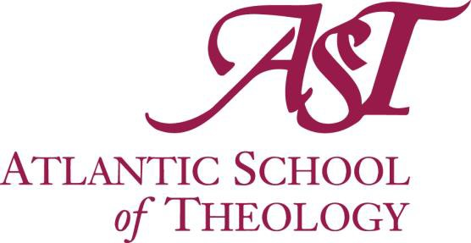

CALL FOR 2024 NOMINATIONS FOR ASSOCIATES

Purpose:
The naming of Associates of Atlantic School of Theology (AST) is intended to publicly recognize outstanding service to the university and to encourage a continuing relationship between the university and its contributors. A maximum number of five (5) appointments will be made in any year.

Submissions:
The Honourary Degrees Committee invites nominations from the members of the Senate, the Board of Governors, Founding Parties, students in-course and graduates.

Criteria to be applied:
- Length of Service to the AST community
- Significance or quality of contribution to the life and work of the university

All submitted nominations are confidential. No approach is to be made to a candidate. If confidentiality is breached, the Honourary Degree Committee will not proceed with consideration of the candidate.
The Committee considers all received nominations and presents its selection(s) to Senate for approval. Once the President has contacted the recipient(s) and received confirmation of their acceptance, the names of recipients will be made public.

Please make nominations in writing, outlining the reasons for nomination and how the criteria of selection are met by the nominee(s), to:

The Chair of the AST Honourary Degrees Committee c/o The President’s Office
Atlantic School of Theology 660 Francklyn Street Halifax, N.S. B3H 3B5
beth.pyesmany@astheology.ns.ca

Thanks for your participation!
Closing Date for Nominations: January 10, 2024

ASSOCIATES Recipient Nomination Form

Nomination Form

Individual Nominee’s name: (Required)

Email and/or Phone: _________________________________________ (Required)

Nominator’s name: Email:

Address:

City/Town: Province:

Postal Code: Phone:

- We may contact you for information or clarification regarding your nomination.
- The information collected through the application process will be used only to determine the recipient of the Associate degree.

Nominator’s Signature: Date:

