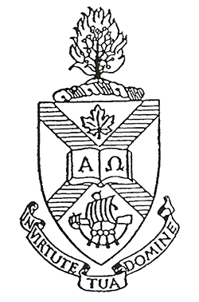
PINE HILL DIVINITY HALL CONTINUING EDUCATION BURSARY GUIDELINES

1. To be eligible, a person must:

a) Be a member of the order of ministry of the United Church of Canada.
b) Have served five years in the ministry of the United Church of Canada.

2. The maximum award is $4,500 and is limited to one year of support.
The bursary may be shared by more than one applicant.
Under normal circumstances, this bursary will be awarded only once to an applicant.

3. Applications must be in writing and stating:
- The course of study intended and at which institution.
- The budget of the proposed financial arrangements for the study.
- Applications must include complete financial plans and include amounts coming from Pastoral Charge Education Allowances (minimum $1,200).
- A statement indicating why the applicant has chosen this course of study, and what the applicant hopes to learn about pastoral ministry through this study.

4. The successful applicant will report back to the Pine Hill Bursary Committee within three months of completion of the course of study, addressing the following points:
a) How the course of study helped the applicant in her/his Christian Walk.
b) How the course of study is or will be applied and used in the applicant's pastoral ministry.

5. Applications must be made by February 1st, before commencement of study.

6. Applications are to be sent to:
Brenda Munro
Secretary to the Board of Governors
Pine Hill Divinity Hall
660 Francklyn Street, Room #124
Halifax, NS B3H 3B5
Phone: 902-423-3158
E-mail: pinehill@astheology.ns.ca

